PAAREES Perfumes

Diesel Women

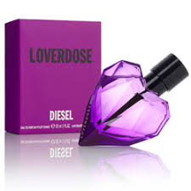

**Diesel for Women - 100ml**

Key Features

* Antibacterial formula with golden ions
* Without alcohol and colorants
* Skin tolerance
* Dermatologically proven.